Interview with Kim YoungSeon Teacher

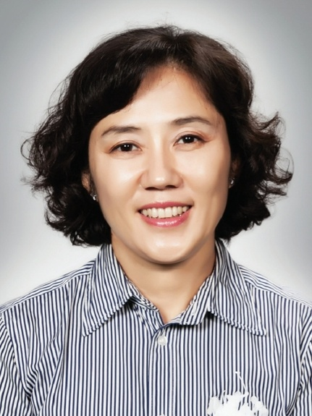
7106 Kim HyenSeong

1. Why did you choose to come to Wuxi Korean School?
I originally worked at Wuxi Korean School from 2013 to 2018, a total of 5 years. WKS are the first school I worked at in China, so I wanted to come here again. I like Wuxi Korean School and their students.

2. What was the hardest thing you experienced in China during the COVID-19 pandemic?
Middle and high school students, followed by elementary students started coming back to school in April, so I feel like school started twice in one semester.

3. What do you think is good about Wuxi Korean School?
I think the textbooks here are more fun because schools in Korea and China have different textbooks; WKS has more variety to their topics of their textbooks.

4. What is your future plan?
As a teacher, I have vacation time coming up. I want to spend my vacation traveling. I like to travel because when I teach students about a specific place, I will be able to tell them about it by referring to my experience and it will be easier for them to understand.

5. What do you think are the differences between schools in Korea and WKS?
In Korea, they are currently reducing English contests because Korea is being standardized. But in WKS, we have more contests and our textbooks are different.

6. How did you feel about China when you first came here?
When I first came to China, I thought that China is huge. China also has an abundance of fruits and China gives me a comfortable feeling.

Interview with Jacob Teacher

10105 Kim Eunseo
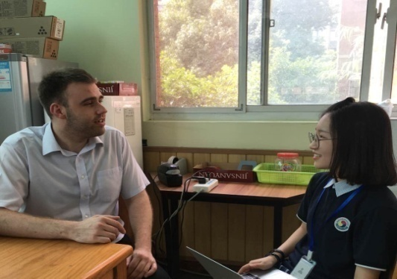
1. Please introduce yourself.
Hi, my name is Jacob, and I’m from Britain!

2. What is your hobby?
I’m quite sporty, I like playing sports and especially running when there’s an event.

3. Why did you come to WKS?
I needed a new challenge and had a chance to come to China because Chinese was my second language after English. My previous job was working with senior high school students, and it was an opportunity to work with elementary people.

4. What do you want to achieve in WKS?
I hope to have more experiences and want to improve myself. I saw those elementary students are weak at speaking and listening, so I want to make them confident when they speak!

5. If you can tell something to someone who wants to become an English teacher, what do you want to say?
Uh, for me… I did a course, which took three months, but I didn’t get my first role as English teacher until 2017 September. I was too afraid to apply jobs, because the good jobs I want were 10 thousand kilometers away, and different cultures and being far away made me afraid, even writing applications. So, what I want to say is just don’t worry about if you are rejected to interview, there would be still more chances!

6. What are some hardships you had when you came to China?
I would say communication, or language barrier is a big obstacle. Even I tried my best to say something in Chinese, and if I get one tone wrong, the meaning of the word changes. The word ‘xie’ means shoes, and also means the name of food. When you go to restaurant and order ‘xie’, the staff says “why are you finding shoes in restaurant?” with a strange stare.

7. What do you think is the best thing when you came to China?
I like the fast transportation! The place where I lived before coming to China, doesn’t have many transportation options. It took two hours to get to my friend’s house, and closed at 10, so it was hard to meet my friends. But here, it doesn’t really take much to get my friend’s house, so I think this is the best thing.

8. Do you have any last words?
Well. I didn’t think about this. Just no matter which country you are in, I would say the most important things are these two things, your passions even you have nothing and your behavior towards others!

Interview with Kim JungKyung Teacher

12109 Park HyunJi

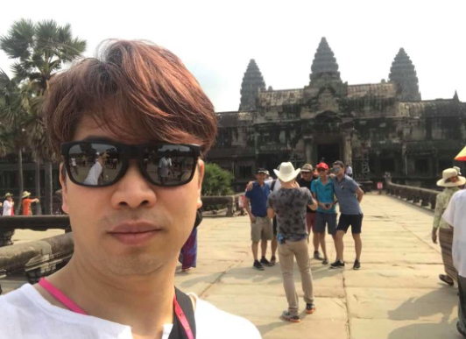
1. Can you introduce yourself to us?
Hi. I am Kim JungKyung and I was asked to come to WKS to teach physics unexpectedly. I am actually a homeroom teacher for Suzhou Korean School’s seniors.

2. What was your first impression on WKS students?
I had the thought that WKS students were very lively. They had blooming expressions that you cannot find in students in Korea and they smiled at me, a stranger, by showing their white teeth.

3. How long have you lived in China and is there any fun episode while living here?
I came to China last year. Once during my vacation, my family went to a shopping mall and a Chinese person came up to my second kid and asked whether or not we want to make him an actor. That person followed us to a restaurant.

4. What are the advantages and hardships for you to come to WKS every week?
The advantage is that I am able to feel our 12-2’s passion towards difficult physics! There are no hardships for me.

5. What do you normally do during your leisure time?
I stay away from books when I rest. I like to play sports. Recently, I am into golf.

6. Please give us some advice for studying!
Not falling asleep during class and organizing your class notes neatly.

7. How do you relieve your stress?
I exercise a lot. I become a health boy during the weekends.

8. Can you tell us what made you to become a physic teacher and physic’s charm?
I became a physics teacher because my senior homeroom teacher told me, “You should just major in physics.” Physics is charming because it is a subject which “anyone as lazy as I can do.”

9. Any last words?
First of all, I am thankful to the principal and teacher of WKS to allow me to have two jobs in WKS. Also, to my students, I wish you all can become a ‘global citizen’ with this background of living aboard. It was a fun and happy experience for me.

Interview with Jang KookJin Teacher

8216 Kim EunJi
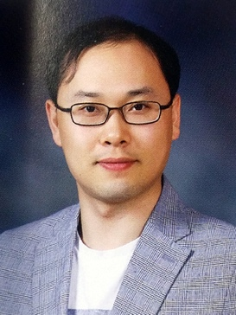
1. Please introduce yourself.
Hi I am Jang Kookjin, a teacher in charge of Korean language in secondary school. This is my first year coming to China and I taught students in Yong In, Korea. I am currently the homeroom teacher of 8-1.

2. What was the reason for you to come to WKS?
While I was teaching students in Korea, I learned about overseas Korean schools and began preparing for it. I wanted to teach students who were not in Korea, and I wanted my children to have new experience of school life outside of Korea.

3. Do you have any goals you want to achieve in WKS?
My goal is to guide my homeroom students well for a year, watching them achieve their goals well until they graduate.

4. What is the reason that you became a Korean language teacher?
It is because I like to be with young students and it is joyful to let students to know about our literature.

5. What do you want to say to the students who are dreaming of working in the Korean language field?
First of all, they should know how to enter the Korean language departments and prepare according to what they require and I think students will become great teachers if they get the necessary skills as a Korean language teacher.

6. What are the difficulties or conveniences of coming to China?
Around the time I decided to come to China, the COVID-19 incident occurred, and I had a lot of worries about myself and my surroundings. The inconvenience was that there were too many limitations due to COVID-19, however, I still remember many teachers helping me with solving COVID-19 related problems.

7. Were there any differences between teaching students in Korean and in China?
Currently, I am teaching students from the first grade of elementary school to the second grade of high school. In my opinion, the experience of meeting all students in elementary, middle, and high school, it’s very valuable that I can never experience at schools in Korea.

8. Lastly, leave a message for all students.
I wish you all can keep on improving yourselves and remain the pure and nice impressions that WKS students have until the end.

Interview with our new teacher, Seo Pyeong Joo

7113 Lee Woo Jae
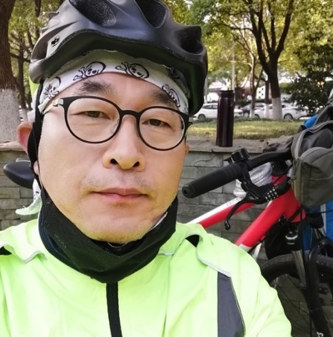
1.Please introduce yourself.
Hi, my name is Seo Pyeong Joo. My nick name is PJ. My hobbies are bicycle riding, swimming and doing kendo. My hometown is Yeosu. I also like to study English with my students.

2. How do you feel about coming to WKS?
It has not been long since I came to WKS, but at the moment I am very excited to come to this school and be here.

3. What do you teach?
Overall, I teach English. I teach Grade7 and 10 English and I’m also in charge of Grade11’s English Literature and culture.

4. What are some good and bad things about WKS?
A4: I think it is warm hearted, friendly, charming and also very neat. But the one thing that I would fix is the front door waterway. In total, I think WKS is one of the best schools that I have been to and worked in.

5. Do you think the students of WKS are doing well?
I think they have good knowledge and understanding skills. I am satisfied with their ability. They have very good manners. I like that they show respect to me and their classmates. I also heard that students of WKS have very good ability in P.E. (physical education).

6. Why did you decide to come to WKS?
In 2017 and 2018 I was working in Shanghai Korean School and the facilities were very good so I didn’t think about moving to WKS. But in 2019, because of domicile problems, I went to Korea but after a while I was able to come back to china and joined WKS. Now I could see my wife and son that were left behind when I went back to Korea.

Interview with our new teacher, Lee Min Woo

10103 Kim Seoyeong

1. Can you introduce yourself shortly?
Hello, my name is Lee Min Woo who started working as a P.E. teacher in WKS this year.

2. What is the reason you came to WKS?
Working as P.E. teacher, I have always wanted to meet students who lived abroad. Plus, I’ve wanted to know what dreams they had.

3. What was your first impression when you came to WKS?
Most of the P.E. teachers would first look at the quality of P.E related materials such as natural grasses with well cared for gyms. When I first saw those, I was excited that I could teach many students here.

4. What is your goal you want to achieve in WKS?
My goal in WKS is to help students who want to enter the Department of Physical Education. To be more specific, I wanted to create the best P.E. teachers in the world. Haha

5. What is the reason you became a P.E. teacher?
When I was in High School, I loved sports, so I think I eventually went into the Department of Physical Education and became a P.E. teacher.

6. If you can say something to students who want to be a P.E. teacher, what would you say?
In my opinion, if you like sports then you might feel much satisfaction and fun being a P.E. teacher. If anyone is dreaming becoming a P.E. teacher, feel free to come and ask me! I will guide you.

7. Anything you struggled with when you came to China?
It was when the COVID-19 began to spread around when I came to China. So, I had to start my life here with quarantine which was so stressful. However, there are relatively cheap prices in China and an enjoyable life in WKS, I think I have adapted here very quickly.

8. What do you think WKS students’ advantages are?
I think WKS students have more sparkling eyes than Korean students. An eye for drawing and designing their future self-directly.

9. Any last words you want to say to WKS students?
I want to say that it is important to study hard, but also have a lot of experiences too. It helps you, whether you are successful or not. Lastly, remember that the main character in your life is only one, you!! 加油!

Interview with our new teacher, Jung Yoon Sik

12116 Lee youmi

1. Introduce yourself
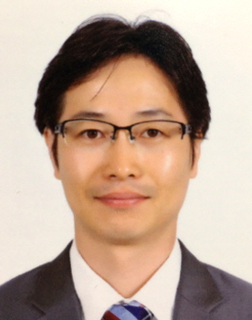
Hello! I'm JungYoon Sik, in charge of Korean. I'm so happy to meet you guys at MuSuck Korean School and I'm really looking forward to it. Although I got off to a rough start with the Corona-19, I hope the journey here will be the brightest and most beautiful time in my life and in your life. As I said, 'Happy people don't look at clocks,' I want to thank the given life for every moment and pioneer a happy life. So I like various experiences and challenges, and I believe in 'the law of 10,000 hours', and once I start, I try until the end.

2. What made you become a teacher?
"You're the perfect teacher." It's something I've heard from my friends since high school. At that time, I didn't like this word so I got angry with my friends. But like a prophecy, it's become a teacher. I love teachers who can serve and teach as lifelong work. Now that the first disciple has become a father of a child and is getting old together, I am especially grateful that I can always meet young souls.

3. What made you come to Korean school in MuSuck?
A few years ago, when I climbed Machu Picchu in Peru, I suddenly remembered a dream I had forgotten. Thinking that nothing is everlasting in the world like the Inca Empire, I felt that I could no longer postpone my dream of becoming a teacher. While I was preparing for various Korean schools, I happened to read the blog of my teacher who worked at "MuSuck Korean School" and thought it was a good place to apply. Despite the concerns and dissuasion around me, I came here to meet you through the Corona.

4. What are the good things about coming to China?
In fact, for the first time in my life in China, I did self-price and nuclear acid tests, and had various experiences, but I still miss Korea a little bit. But I feel a little comforted because I can eat as much fruit as I like. And if you put it in soybean paste soup, stew, and ramen, your family hates it, but you can eat the cilantro (champs-chai) you like every meal. But the best thing about it is that we're meeting you, building each other's dreams, and spending time together that we can't come back.
5. What are the difficulties in China?
To be honest, it's really hard for me to smoke too much personally, rather than having trouble communicating or having no cars. Smoking is the most difficult thing even at the gym or sauna. But wherever you go, you can't miss it. I always try to thank you positively without complaining, but the smell of cigarettes is still hard....

6. What are some of the specialities or advantages of our school?
A school where talented and passionate teachers and polite and cool students learn and grow. A school where one can watch each other grow from kindergarten to high school. So I think that MuSuck Korean School is the coolest school in Hwadong area.

7. Any last words?
If you look at your life clock, it's not even 5 a.m. yet. If you dream, hope, and think early in your preparation for Dawn (黎明), you will be able to achieve anything. As the saying goes, "Even small efforts must be repeated to make your dreams come true," I hope you will dream and strive to pioneer a precious, wonderful, and wonderful life that everyone wishes for.

